**Exercise 3: Stored Procedures**

**Scenario 1:** The bank needs to process monthly interest for all savings accounts.

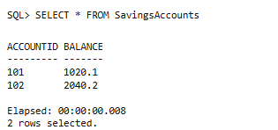

**Scenario 2:** The bank wants to implement a bonus scheme for employees based on their performance.

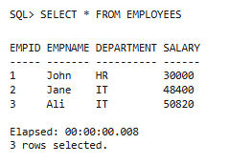

**Scenario 3:** Customers should be able to transfer funds between their accounts.

